IPQC Database Backup & Restore
User Guide for the Supabase-based IPQC System (Docker Desktop, Windows)

1. Overview
This guide explains how to back up and restore the IPQC system's database and file storage. The IPQC system runs on a self-hosted Supabase instance inside Docker Desktop, consisting of a database container (supabase-db) and a file storage container (supabase-storage).
Two scripts are used:
- Backup_IPQC_DB.ps1 — creates a timestamped backup of the database and storage files.
- Restore_IPQC_DB.ps1 — restores the database and storage files from a chosen backup.
All backups are stored under:
C:\Users\Acer\IPQC_Project\backups
Each time the backup script runs, it creates a new subfolder named with the date and time, e.g. 20260701_114018. Inside that folder you will always find:
- database.dump — a complete PostgreSQL database dump.
- storage — a copy of all files stored by the system (photos, attachments, etc.).

2. Prerequisites
Before running either script, make sure the following are true:
- Docker Desktop is installed and running. Look for the whale icon in the Windows system tray — it should be steady, not animating.
- The supabase-db and supabase-storage containers are running. Check with the command below.
- PowerShell is available (built into Windows).
docker ps
You should see both supabase-db and supabase-storage listed with a status of Up. If Docker Desktop was just started, wait 15–30 seconds before proceeding, as the database may still be initializing.

3. First-Time Setup (Once per Computer)
Windows blocks unsigned PowerShell scripts by default. The first time you run either script on a computer, you may see an error such as “cannot be loaded... is not digitally signed.” Resolve this once as follows.

3.1 Allow local scripts to run
Open PowerShell and run:
Set-ExecutionPolicy -Scope CurrentUser RemoteSigned
Type Y and press Enter to confirm.

3.2 Unblock the script files
If a script was downloaded or copied from another computer, Windows marks it as coming from the internet, which blocks it even after the step above. Unblock each script once:
Unblock-File -Path ".\Backup_IPQC_DB.ps1"
Unblock-File -Path ".\Restore_IPQC_DB.ps1"
Note: You only need to do this once per script, per computer — unless the file is re-downloaded, in which case it will need to be unblocked again.

4. Creating a Backup

4.1 Steps
- Open PowerShell.
- Navigate to the folder containing the script, for example:
cd "C:\Users\Acer\IPQC_Project"
- Run the backup script:
.\Backup_IPQC_DB.ps1
- Wait for the script to finish. It will print progress messages and finally confirm the backup location, e.g.:
Done! Backup saved to: C:\Users\Acer\IPQC_Project\backups\20260701_114018

Example: Running the Backup Script
Navigate to the backups folder:
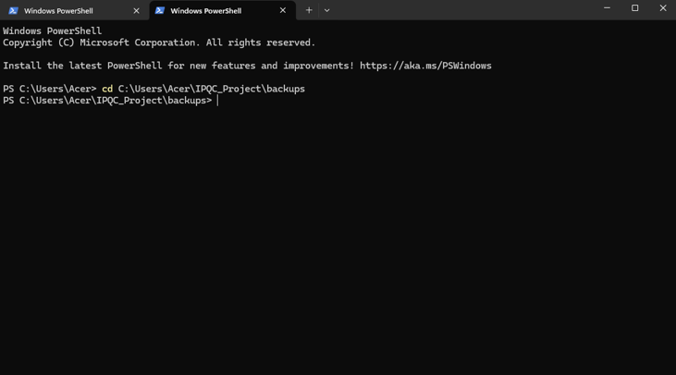
Figure 1 — Navigating to C:\Users\Acer\IPQC_Project\backups
Then run the backup script. A successful run looks like this:
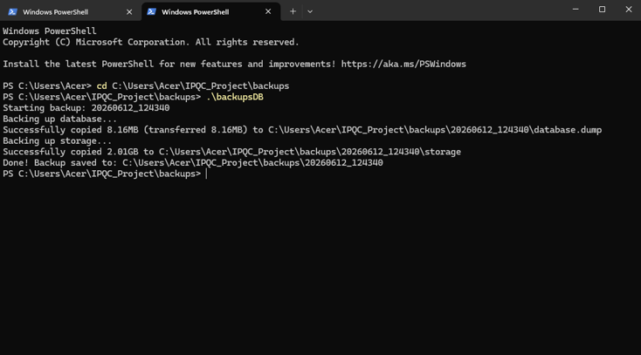
Figure 2 — Backup_IPQC_DB.ps1 completing successfully, saving to a new timestamped folder

4.2 What the script does
- Creates a new timestamped folder inside C:\Users\Acer\IPQC_Project\backups.
- Dumps the entire PostgreSQL database from the supabase-db container and saves it as database.dump.
- Copies all files from the supabase-storage container into a storage subfolder.

4.3 Recommended backup frequency
Run a backup regularly (for example, daily or before any major change to the system) and always immediately before performing a restore, so that the current state is not lost if something needs to be undone.

5. Restoring from a Backup
Warning: Restoring overwrites the current database and storage with the contents of the chosen backup. Any data created after that backup was taken will be lost unless a fresh backup is taken first. Always back up the current state before restoring, if that data matters.

5.1 Steps
- Open PowerShell and navigate to the folder containing the restore script.
- Confirm Docker Desktop is running and both containers show Up (see Section 2).
- Run the restore script. To restore the most recent backup automatically:
.\Restore_IPQC_DB.ps1
- To restore a specific backup instead, pass its folder name:
.\Restore_IPQC_DB.ps1 -BackupDate "20260701_114018"
- When prompted, type YES and press Enter to confirm the overwrite.
- Wait for the script to complete. It will report progress through each stage: database restore, storage restore, and container restart.

Example: Running the Restore Script
A successful run, restoring the most recent backup, looks like this:
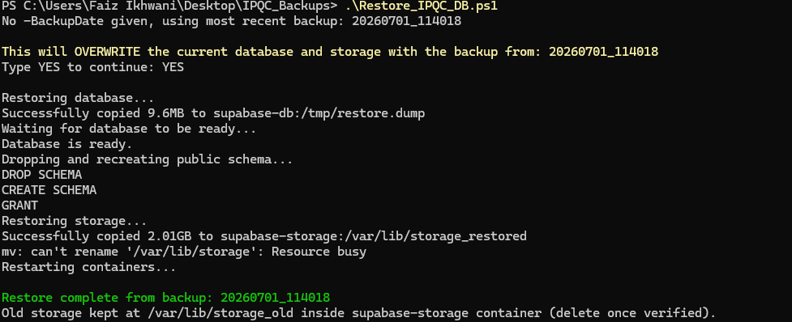
Figure 3 — Restore_IPQC_DB.ps1 completing successfully
Note: In this example run, the storage swap step reported “mv: can't rename '/var/lib/storage': Resource busy.” This means the storage container had the folder in use at that moment, so the old storage was not renamed to storage_old as expected. If you see this message, check /var/lib/ inside the supabase-storage container directly to confirm which folder (storage or storage_restored) is actually active before relying on the swap having completed.

5.2 What the script does
- Locates the chosen backup folder (or the most recent one, if none is specified).
- Waits for the database container to be ready to accept connections.
- Drops and recreates the public schema in the database, then restores all tables from database.dump into it.
- Copies the backed-up storage files into the supabase-storage container, keeping the previous storage as storage_old inside the container as a safety copy.
- Restarts both containers so the application picks up the restored data.

5.3 Confirming the restore succeeded
The script prints “Restore complete” when finished. After that, open the IPQC application and check that recent records and files appear as expected for the backup date chosen.

6. Cleaning Up After a Restore
The restore script keeps the previous storage files inside the supabase-storage container at /var/lib/storage_old, as a safety net. This path is inside the Docker container, not on the Windows file system, so it must be accessed through Docker commands.

6.1 Viewing the old storage copy
To list its contents without entering the container:
docker exec -t supabase-storage ls -la /var/lib/storage_old
To copy it out to Windows for a closer look in File Explorer:
docker cp "supabase-storage:/var/lib/storage_old" "C:\Users\Acer\Desktop\storage_old_check"

6.2 Deleting it once verified
Once you have confirmed the restored data is correct and the old copy is no longer needed, free up space with:
docker exec -t supabase-storage rm -rf /var/lib/storage_old

7. Troubleshooting
Common issues and how to resolve them:
Symptom | Resolution
Script “cannot be loaded... not digitally signed” | Run Set-ExecutionPolicy -Scope CurrentUser RemoteSigned, then Unblock-File on the script (see Section 3).
“The system cannot find the file specified” / dockerDesktopLinuxEngine pipe error | Docker Desktop is not running. Open it from the Start menu and wait until the whale icon is steady, then retry.
pg_restore: “the database system is starting up” | The database container just started and needs a few seconds to become ready. The restore script now waits automatically; if running commands manually, wait and retry docker exec -t supabase-db pg_isready -U postgres.
“must be owner of event trigger...” during restore | Use the supabase_admin role rather than postgres when restoring — this is handled automatically by the restore script.
“cannot drop constraint... because other objects depend on it” | This happens with --clean when tables have foreign key dependencies. The restore script avoids this by dropping and recreating the whole public schema instead.
“schema “_realtime” already exists” (or similar for auth/storage schemas) | The dump includes Supabase's internal schemas, which should not be restored. The restore script restricts the restore to the public schema only.

8. Quick Reference

8.1 Backup
.\Backup_IPQC_DB.ps1

8.2 Restore (most recent backup)
.\Restore_IPQC_DB.ps1

8.3 Restore (specific backup)
.\Restore_IPQC_DB.ps1 -BackupDate "YYYYMMDD_HHMMSS"

8.4 Check Docker containers are running
docker ps

8.5 Check database is ready
docker exec -t supabase-db pg_isready -U postgres

For questions about this system, contact the VIGOR Digital Solution team.

